Svg Cutter is a program used to cut out ROI’s from images of specified reference by using an one preferred image of reference, marked with points of interest and converted into svg file.

Steps:

1. Create a file structure similar to the one provided in test folder.
2. From collected images of one reference, select a preferred image stored in BIG folder and open it in software which can edit and convert it into an svg file (for example Inkscape).

2.

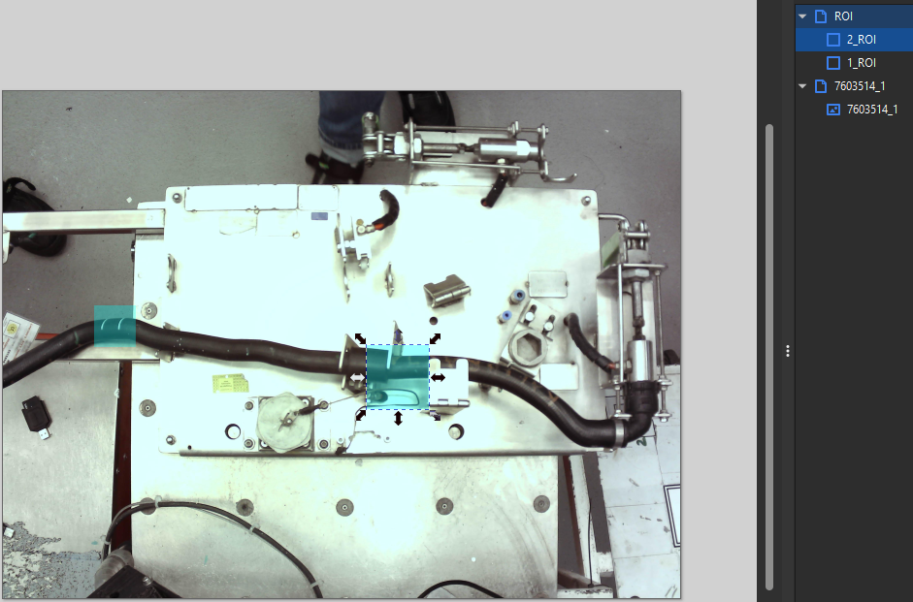

You must create an group which will contain ROI’s, each ROI (blue square) must be named in similar style for each point of interest (1_ROI, 2_ROI….N_ROI), the image name must be in style of: {reference name}_{which camera} (2nd group in the image.

Save the file.

3. Run the program, do as the buttons save, the results will be stored in the same directory as the selected SVG file and BIG file.

The buttons:

1. Edit example: Specifies how many types of folders should be there for easier sort of results (for example, you can create 4 different groups OK, NOK, Human_ERROR, Gloves)

2. Select BIG file: As the button says, must point to folder containing all BIG images of reference

3. Select SVG file: As the buttons says, must point to SVG file with specified parameters.

4. Start: Starts program

Folders:

Config: Contains config text file, in which you can change the resolution of images before starting the process

Example: Contains most required files, the files must be named this way, the example.tflite must be of similar weight (2042 KB) and must be manually copied in case of moving the program between users, other files will be generated on first program run

Test: Contains a svg file and a BIG file containing one image of reference used to test the software

_internal: All files required to even start the program